ENGL 3110 - Exam One - Spring 2025
Total Points: 100 - Time: 70 Minutes
Resources: Anything except help from other people or AI/LLM (ChatGPT, etc)
Sections:
- Multiple Choice: 30 points (15 questions, 2 points each) - Suggested Time: 20 minutes
- Short Answer: 25 points (5 questions, 5 points each) - Suggested Time: 10 minutes
- Sentence Labeling and Diagramming: 30 points (5 diagrams, 6 points each) - Suggested Time: 25 minutes
- Essay: 15 points (1 question) - Suggested Time: 15 minutes
- Bonus: 10 points, 5 questions (2 pts each)

STUDENT NAME: ________________________________________________________

Section A: Multiple Choice (30 points)
Section A1: Descriptive vs Prescriptive Rules (4 questions, 8 points)
Question 1: Which of these is the best example of a prescriptive rule? (2 pts)
Answer: _____
a. In English, most questions begin with a wh-word or auxiliary verb
b. In English, the subject typically appears before the verb
c. In English, educated speakers never say "ain't"
d. In English, adjectives usually come before the nouns they modify

Question 2: Which of these is the best example of a descriptive rule? (2 pts)
Answer: _____
a. In formal writing, you should never begin a sentence with "And"
b. In English, contractions like "don't" are inappropriate in academic writing
c. In English, questions typically begin with a wh-word or auxiliary verb like did, be, or has
d. In English, proper speakers avoid double negatives

Question 3: A linguist observes that children learning English typically acquire the past tense "-ed" ending before they learn irregular past tense forms. For example, a child might say "I walked to school" and "I played outside" before correctly saying "I went to the store" (instead of "I goed"). The tendency to apply the regular -ed ending is best described as: (2 pts)
Answer: _____
a. A prescriptive rule arising naturally from the language
b. A descriptive rule describing how the language is typically acquired
c. A prescriptive guideline developed by experts
d. A descriptive rule developed by experts and enforced on a particular social group

Question 4: Which of these options best describes the rule “In formal writing English, you should not begin a sentence with a coordinating conjunction like “But” or “And”? (2 pts)
Answer: _____
a. Descriptive rule based on patterns followed in every spoken dialect
b. Prescriptive rule based on style preferences
c. Descriptive rule based on the biological theory of universal grammar
d. Prescriptive rule acquired naturally by all writers without explicit instruction

Section A2: Open and Closed Classes (4 questions, 8 points)
Question 5: Which of these words belongs to an "Open Class"? (2 pts)
Answer: _____
a. Through
b. Magnificent
c. Which
d. Them
Question 6: Which of these words belongs to a "Closed Class"? (2 pts)
Answer: _____
a. Brilliant
b. Swimming
c. Underneath
d. Teacher
Question 7: New words are most likely to be added to which word class? (2 pts)
Answer: _____
a. Prepositions
b. Determiners
c. Verbs
d. Pronouns

Question 8: Which word class is considered "closed" because it rarely gains new members? (2 pts)
Answer: _____
a. Nouns
b. Adjectives
c. Determiners
d. Adverbs
Section A3: Parts of Speech (7 questions, 14 points)
Question 9: In the sentence below, which word is functioning as an adverb? (2 pts)
Sentence: Three playful kittens carefully explored the mysterious basement.
Answer: _____
a. Three
b. Playful
c. Carefully
d. Mysterious
Question 10: In the sentence below, which word is functioning as an adjective? (2 pts)
Sentence: Three playful kittens carefully explored the mysterious basement.
Answer: _____
a. Three
b. Kittens
c. Explored
d. Playful
Question 11: In the sentence below, which word is functioning as a verb? (2 pts)
Sentence: During the storm, Maria's grandmother quietly knitted warm scarves for her grandchildren.
Answer: _____
a. Storm
b. Quietly
c. Knitted
d. Warm
Question 12: In the sentence below, which word is functioning as a noun? (2 pts)
Sentence: Sometimes, dedicated students carefully review their notes before important exams.
Answer: _____
a. Dedicated
b. Review
c. Carefully
d. Notes
Question 13: In the sentence below, which word is functioning as a preposition? (2 pts)
Sentence: My sister and I walked through the park with our energetic dog after dinner.
Answer: _____
a. Through
b. Sister
c. Walked
d. Energetic
Question 14: In the sentence below, which word is functioning as a determiner? (2 pts)
Sentence: My sister and I walked through the park with our energetic dog after dinner.
Answer: _____
a. Through
b. Park
c. Our
d. Energetic
Question 15: In the sentence below, which word is functioning as a noun? (2 pts)
Sentence: My sister and I walked through the park with our energetic dog after dinner.
Answer: _____
a. Dinner
b. And
c. Through
d. With

Section B: Short Answer - Morphology (25 points)
Instructions: Divide each word into all of its separate morphemes. Identify each morpheme as "free" or "bound."
Example: Unfortunately
  - Un – bound
  - Fortune – free
  - Ate - bound
  - Ly - bound

Question 16: (5 pts) Word: "reloaded"
- Re – bound
- Load – free
- -ed - bound

Question 17: (5 pts) Word: "co-teachers"
- Co – bound
- Teach – free
- -er – bound
- -s - bound

Question 18: (5 pts) Word: "unfriendliness"
- Un – bound
- Friend – free
- Ly – bound
- -ness - bound

Question 19: (5 pts) Word: "disagreements"
- Dis – bound
- Agree – free
- Ment – bound
- -s - bound

Question 20: (5 pts) Word: "preprocessing"
- Pre – bound
- Process – free
- -ing - bound

Section C: Sentence Labeling (30 points)
Instructions: For each sentence below, take two steps.
- Label the words and phrases.
- Draw a tree diagram as we have practiced in class.

At the end of this exam, you can find several blank pages to use for practicing your diagrams if you choose to.
Key
Parts of Speech  - Noun = N  - Verb = V  - Adjective = Adj  - Adverb = Adv  - Determiner = Det  - Preposition = Prep  - Pronoun = Pro  - Interjection = Intj  - Conjunction = Conj  - Relativizer = Rel  - Complementizer = Comp  Phrase Types  - Noun Phrase = NP  - Verb Phrase = VP  - Adjective Phrase = ADJP  - Adverb Phrase = ADVP  - Prepositional Phrase = PP | Roles  - Subject = Subj  - Predicate = Pred  - Adverbial = Advl  - Subject Complement = SC  - Direct Object = DO  - Indirect Object = IO  - Object Complement = OC  Clauses  - Sentence = S  - Independent Clause = IC  - Dependent Clause = DC  - Relative Clause = RC  Complement Clause = CC

Notes
- You are always encouraged to look over the example diagrams and other handouts found on the front page of Canvas to assist you with diagramming and labeling.
- As we discussed in class, some of the “phrase” boxes may not cover all of the words in that phrase. Please make your decision by identifying the headword of the section contained under that box. Use that headword to determine the type of phrase and, when necessary, its role in the sentence.
- You do not need to include the “roles” in your diagram unless you are specifically asked.
- Always include a phrase level for nouns, verbs, adjectives, adverbs, and prepositions
- Label Possessive Nouns as Nouns with an NP even though they appear in the determiner position
- Some parts of speech fill the role for other parts of speech. For instance, a verb can take a noun position and serve as a subject. In this case, either label is ok on the diagram, as long as the lines are in the right position.

Example
Example: Three ambitious students from Pueblo study in the library.
Phrase | NP |  |  | PP |  | VP | PP
Word | Three | ambitious | students | from | Pueblo | studied | in | the | library
Part of Speech | Det | Adj | N | Prep | N | V | Prep | Det | N

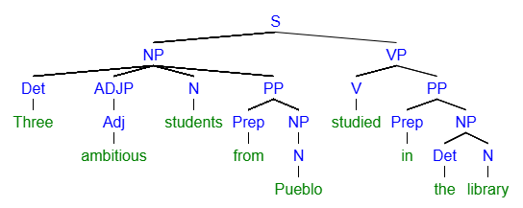

Question 21: (5 pts) Sentence: All brave people advocate for their rights.
Phrase | NP |  |  | VP | PP
Word | All | brave | people | advocate | For | their | rights.
Part of Speech | Det | Adj | N | V | Prep | Det | N

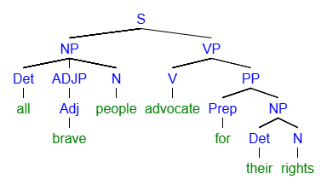
[S [NP [Det all] [ADJP [Adj brave]] [N people]] [VP [V advocate] [PP [Prep for] [NP [Det their] [N rights]
Question 22: (5 pts) Sentence: The professor with the briefcase disappeared suddenly.
Phrase | NP |  |  |  |  | VP | ADVP
Word | The | Professor | With | The | Briefcase | Disappeared | Suddenly.
Part of Speech | Det | N | Prep | Det | N | V | Adv

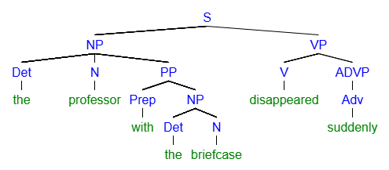
[S [NP [Det the] [N professor] [PP [Prep with] [NP [Det the] [N briefcase]]]] [VP [V disappeared] [ADVP [Adv suddenly]
Question 23: (5 pts) Sentence: Maria carefully peered into the microscope.
Phrase | NP | VP |  | PP
Word | Marie | Carefully | Peered | Into | The | microscope
Part of Speech | N | Adv | V | Prep | Det | N

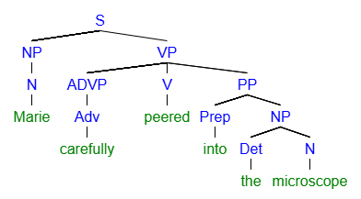
[S [NP [N Marie]] [VP [ADVP [Adv carefully]] [V peered] [PP [Prep into] [NP [Det the] [N microscope]

Question 24: (5 pts) Sentence: Some courage often helps during difficult times.
Phrase | NP |  | VP
Word | Some | Courage | Often | Helps | During | Difficult | Times
Part of Speech | Det | N | Adv | V | Prep | Adj | N

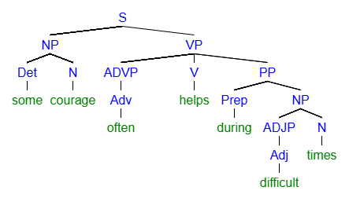
[S [NP [Det some] [N courage]] [VP [ADVP [Adv often] [V helps] [PP [Prep during] [NP [ADJP [Adj difficult]] [N times
Question 25: (5 pts) Sentence: The tall girl with curly hair smiled.
Phrase | NP |  |  | PP |  |  | VP
Word | The | Tall | Girl | With | Curly | Hair | Smiled
Part of Speech | Det | Adj | N | Prep | Adj | N | V

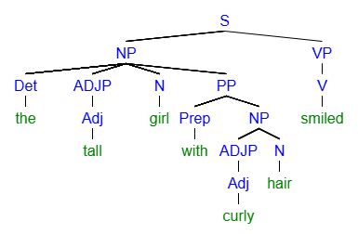
[S [NP [Det the] [ADJP [Adj tall]] [N girl] [PP [Prep with] [ADJP [Adj curly]] [N hair]]] [VP [V smiled]
Essay Instructions are on the next page. I placed the bonus here so you don’t forget about it. Complete the essay first

Bonus (10 pts)
Name a movie, book, or TV show you enjoy: _____________________
Following the instructions below, write an original sentence containing the grammatical feature I specify. The topic of your sentence should be the movie, book or tv show you named above.
- Write a sentence containing an Adjective that is modified by an Adverb. (2 pts)
  - Charlie Sheen is very handsome.

- Write a sentence containing an Adverb modified by another Adverb. (2 pts)
  - Charlie Sheen used drugs very excessively.

- Write a sentence containing two Adverbial Prepositional Phrases. (2 pts)
  - Charlie Sheen acted in Platoon in the 80s.

- Write a sentence containing a Pronoun serving as the Object of a Preposition (Pronoun is the NP in a Prepositional Phrase)
  - Charlie Sheen’s drug dealer was a pretty good friend to him.

- Write a “waterfall” sentence containing a Prepositional Phrase that modifies the Object of another Prepositional Phrase
  - Charlie Sheen’s friend threw him drugs over the wall of the rehab center.

Section D: Essay (15 points)
Time: 15 minutes
Scenario: Bertrand Delacroix is a novelist who has just received an email from his editor, Janet Williams, about a chapter in her upcoming book. The chapter includes this paragraph:
"When Marie got home, she was fixin' to tell her mama about what happened at school. 'Mama, you ain't gonna believe what that teacher said to me today,' she said, sitting down at the kitchen table. Her mama looked up from where she had been cooking. And she wasn't happy. 'Child, you know I don't play when it comes to your education. Tell me everything.' Absolutely everything!"
Janet's email states: "Bertrand, this paragraph contains several grammatical errors that need to be corrected before publication. Professional writing requires standard English grammar, and these mistakes will be distracting to readers and may harm the book's credibility."
Bertrand responds: "Janet, I disagree. This dialogue authentically represents how Marie and her family actually speak. Changing it would be inauthentic to the characters and disrespectful to the communities these speech patterns represent."
Janet follows up: “I understand where you are coming from, Bertrand. But I worry how critics will react. Please consider how the dialogue here will reflect on your non-fiction work in politics and philosophy. Those books are so popular and moving. I would hate to see small errors like this undercut your clout and authority.”

Essay Question: Taking a position that supports either Bertrand or Janet, write a well-organized essay that uses key concepts from our first unit (descriptive vs. prescriptive rules, language variation, standard vs. non-standard varieties) to defend your chosen position. Your essay should demonstrate your understanding of some of these linguistic concepts while making a clear argument about how language should be represented in published literature.
Essay Guidelines:
- Take a clear position supporting either Maya or Janet
- Use specific linguistic concepts from class
- Provide reasoning for your position
- Write in complete paragraphs
- Length: approximately 200-250 words (12-15 sentences)

Essay Response
____________________________________________________________________________________________________________________________________________________________________________________________________________________________________________________________________________________________________________________________________________________________________________________________________________________________________________________________________________________________________________________________________________________________________________________________________________________________________________________________________________________________________________________________________________________________________________________________________________________________________________________________________________________________________________________________________________________________________________________________________________________________________________________________________________________________________________________________________________________________________________________________________________________________________________________________________________________________________________________________________________________________________________________________________________________________________________________________________________________________________________________________________________________________________________________________________________________________________________________________________________________________________________________________________________________________________________________________________________________________________________________________________________________________________________________________________________________________________________________________________________________________________________________________________________________________________________________________________________________________________________________________________________________________________________________________________________________________________________________________________________________________________________________________________________________________________________________________________________________________________________________________________________________________________________________________________________________________________________________________________________________________________________________________________________________________________________________________________________________________________________________________________________________________________________________________________________________________________________________________________________________________________________________________________________________________________________________________________________________________________________________________________________________________________________________________________________________________________________________________________________________________________________________________________________________________________________________________________________________________________________________________________________________________________________________________________________________________________________________________________________________________________________________________________________________________________________________________________________________________________________________________________________________________________________________________________________________________________________________________________________________________________________________________________________________________________________________________________________________________________________________________________________________________________________________________________________________________________________________________________________________________________________________________________________________________________________________________________________________________________________________________________________________________________________________________________________________________________________________________________________________________________________________________________________________________________________________________________________________________________________________________________________________________________________________________________________________________________________________________________________________________________________________________________________________________________________________________________________________________________________________________________________________________________________________________________________________________________________________________________________________________________________________________________________________________________________________________________________________________________________________________________________________________________________________________________________________________________________________________________________________________________________________________________________________________________________________________________________________________________________________________________________________________________________

